# Array Concepts

Basic Array Creation:

Code To **Remove Elements** from an array:

import java.util.Arrays;  
  
public class RemovingelementArray {  
 public static void main(String[] args) {  
 int arr[]=new int[10];  
 for (int i = 0; i < 10; i++) {  
 arr[i]=i+1;  
 }  
 int target = 6;  
 int [] new_arr = new int[10-1];  
 int k=0;  
 for (int i = 0; i < 10; i++) {  
 if(arr[i]==target){  
 continue;  
 }  
 new_arr[k++]=arr[i];  
 }  
 System.*out*.println("Before deletion :" + Arrays.*toString*(arr));  
 System.*out*.println("After deletion :" + Arrays.*toString*(new_arr));  
 }  
}

To find the **length** of the array:

**POINTS ON ARRAY:**

1. array is a collection of similar type of elements which has contiguous memory location.
2. It is a data structure where we store similar elements
3. We can store only a fixed set of elements in a Java array.
4. Array in Java is index-based, the first element of the array is stored at the 0th index, 2nd element is stored on 1st index and so on.

Disadvantages

* Size Limit: We can store only the fixed size of elements in the array. It doesn't grow its size at runtime. To solve this problem, collection framework is used in Java which grows automatically.

**UNDERSTAND ABOUT COLLECTIONS:**

Java Collections can achieve all the operations that you perform on a data such as searching, sorting, insertion, manipulation, and deletion.

Java Collection means a single unit of objects. Java Collection framework provides many interfaces (Set, List, Queue, Deque) and classes ([ArrayList](https://www.javatpoint.com/java-arraylist), Vector, [LinkedList](https://www.javatpoint.com/java-linkedlist), [PriorityQueue](https://www.javatpoint.com/java-priorityqueue), HashSet, LinkedHashSet, TreeSet).





**NOTE:**

For some array based problems we need **Vector,ArrayList,HashMap,HashSet**:

**Hashmap** produces key value pair.

**HashSet** provides an array for storing unique values.

**ArrayList &Vector** for dynamic memory allocation and for performing easy operations.

Others collections will be covered in later weeks.

1)Arraylist:

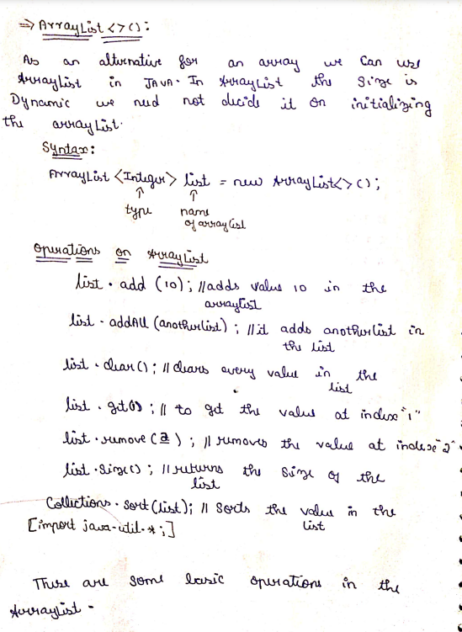

2)HashSet & HashMap:

